Child’s Toy Project Executive Summary

SEPM – GROUP 2 (2022)

**Table of Contents**

Purpose of this document 3

Requirements (Accepted) 3

Prioritisation 4

Development Methodology 4

Project Management Tooling 5

Project Phases / Milestones 5

Project Milestones & Deliverable Summary 7

Project Roles 8

Governance and Delivery Structure 8

Project Key Contacts 9

Communications 9

UAT and Project Acceptance 9

Legal Compliance 10

Estimated Costings 10

Indicative TimeLine 12

References 15

Appendixes 16

Appendix A – Requirements (Gherkin) 16

Appendix B - Demo Requirements Justification 17

Appendix C – Initial UX Design 19

Appendix D – DBMS ERD21

# The purpose of this document:

This document outlines the project, detailing its structure, the boundaries of the project along with the deliverables of the project. The purpose of this project is to develop a child’s toy that is both fun and educational, and that satisfies the requirements proposed by the customer

# Requirements (Accepted):

The following requirements were accepted for inclusion into the solution.

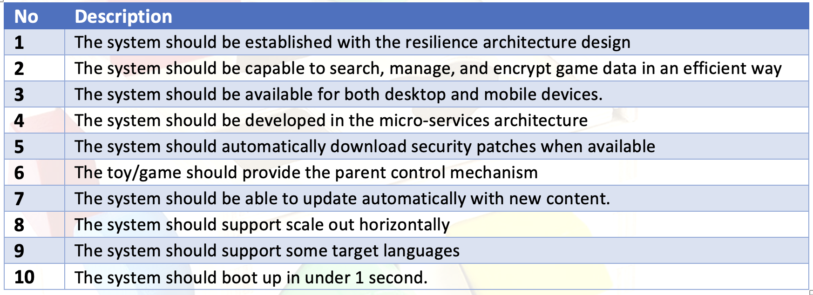

# See Appendix A for Gherkin version of the requirements.

Acceptance of these requirements can be split into a number of categories. Shown in the table below

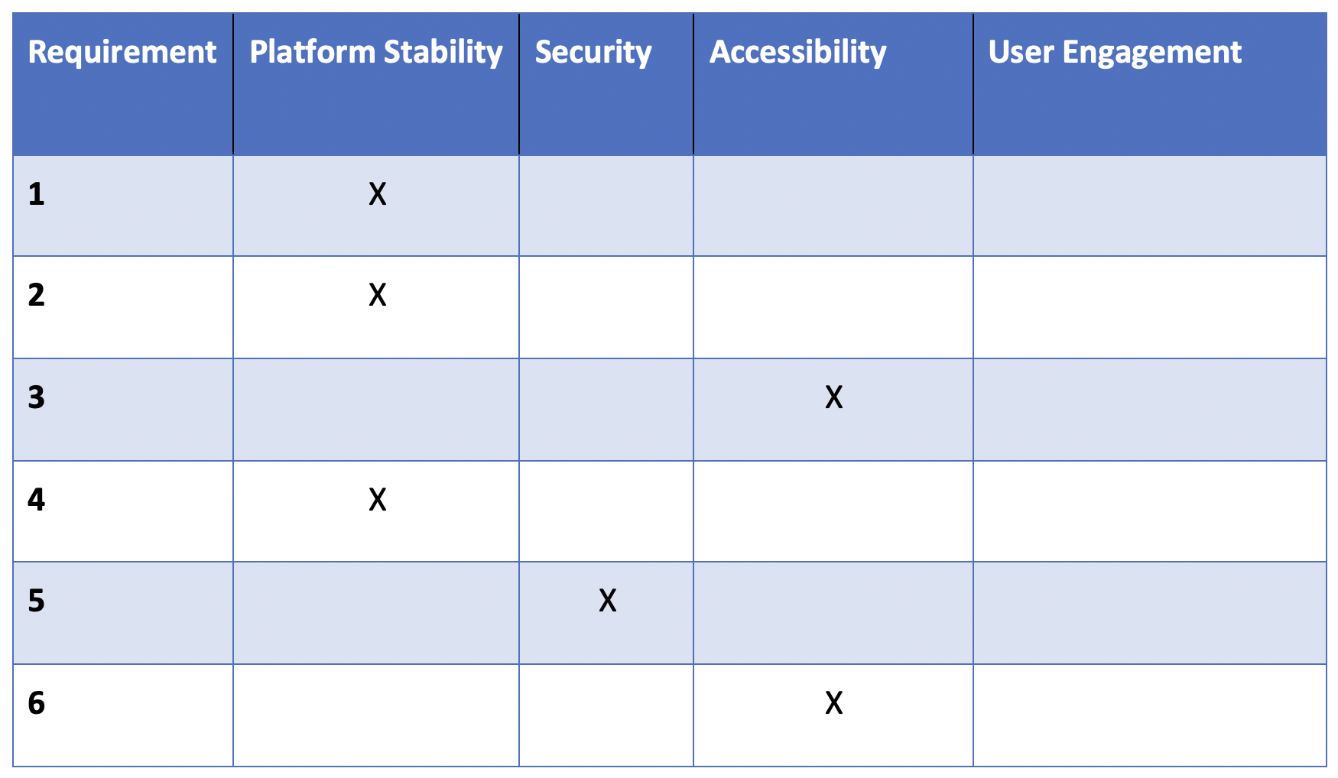

**Table 1**

# Prioritisation:

The game produced needs to be based on solid foundations, as without a good platform delivering a good customer experience, the game won’t succeed in the market. Platform stability and security will be prioritised in the development process over user's engagement.

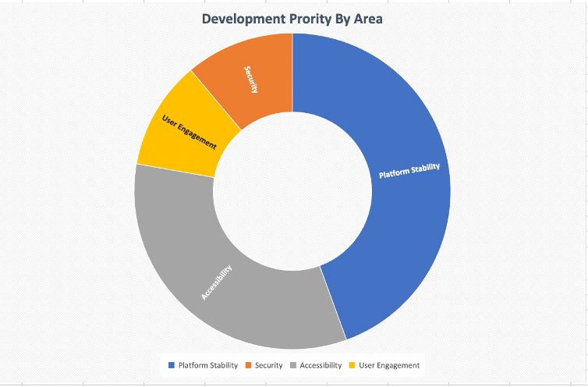

**Figure 1**

# Development Methodology:

Waterfall methodology has been chosen for the following reasons:

It requires business needs and requirements in the beginning. This allows the analysis team to determine the business needs and requirements clearly and precisely, thus facilitating a better outcome in terms of delivering the organisations' needs (Radhika D Amlani, 2012). This is accurate in this instance since we have committed to a set of clear requirements, and committed that we won't change or add to them as the project progresses.

Well-defined activities at each of the stages. The outputs are also defined, and the project can be easily measured against a predetermined timeline (Radhika D Amlani, 2012).

This approach can be quite effective when team members are dispersed across the country or the world. And, the amount of resources required to implement a waterfall model is lower than other methods (Radhika D Amlani, 2012). This is beneficial for our team as we are all dispersed around the world and only have limited resources to work with.

The drawback is that it is more difficult to return to a stage that has already been completed, but as long as the project is well planned, it should not be a problem.

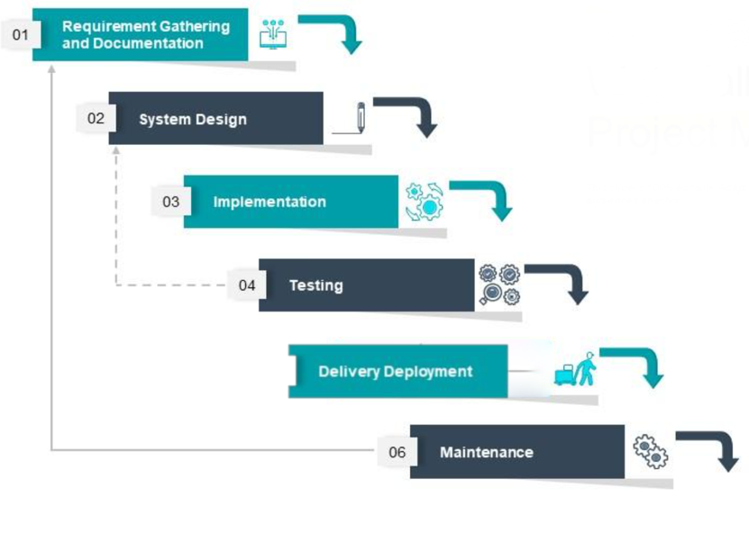

***Figure 1*** (Markovic Isidora, 2020)

# Project Tooling:

The project will be managed using Jira, an industry standard project management tool which supports issue tracking, epics, full application development lifecycle, and multiple plugins. Jira was originally intended purely for software development, but it is now moving into the entire field of project management (Mastný, 2021)

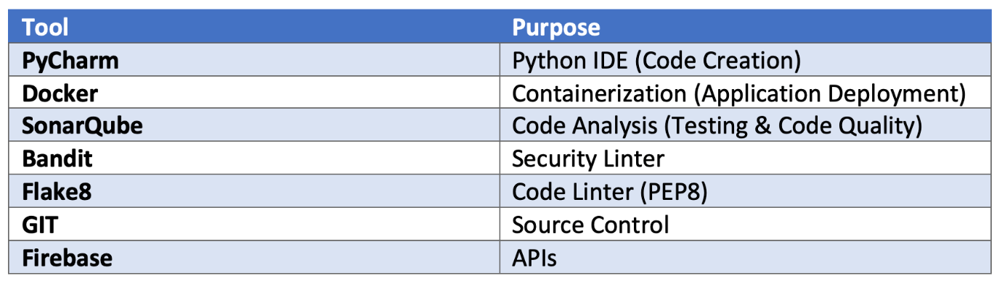**Table 2**

# Project Phases / Milestones:

Project delivery will be split into a number of milestones to align with the tasks being carried out. Where possible, these will be aligned with the seven SDLC phases.

**1. Project Kick off / Initiation**

This phase is focused on putting in the building blocks needed to build an effective project team. Tooling and processes to allow for clear communication between team members and applications needed to enable remote collaborative workflows.

**2. Planning and Requirements**

This phase focuses on getting the system and technical requirements for the solution, ensuring targets and goals set out are achievable in the timeframe specified with the available resources. It is also the stage where a majority of the project documentation will be produced, and that will act as technical guidance on the system requirements of the project.

* Requirements gathering
* Communication plan
* DPIA / GDPR Review

**3. Design**

In this phase, the requirements gathered are ranked and turned into a design that can be delivered. It also encompasses the production of an LLD and HLD document.

**4. Development**

This phase focuses on the creation and delivery of a solution that meets the outlined design. This will be coded in standard PEP8 compliant python 3.x code. As per the specified hard project parameters.

**5. QA (Quality Assurance)**

This phase focuses on the delivery of a working solution via the use of a suite of tests.

* Automated Tests & Unit Tests via a CI/DI pipeline
* Manual tests are carried out by developers
* End-to-end integration of system components is tested using integration tests
* DAST & SAST Security & Compliance Testing

**6. Delivery**

In this phase, the project is made ready for final production, and the solution is passed from the development team to the operational team. Acceptance into the production document produced and reviewed are carried out by project stakeholders.

**Proposed Delivery Plan**

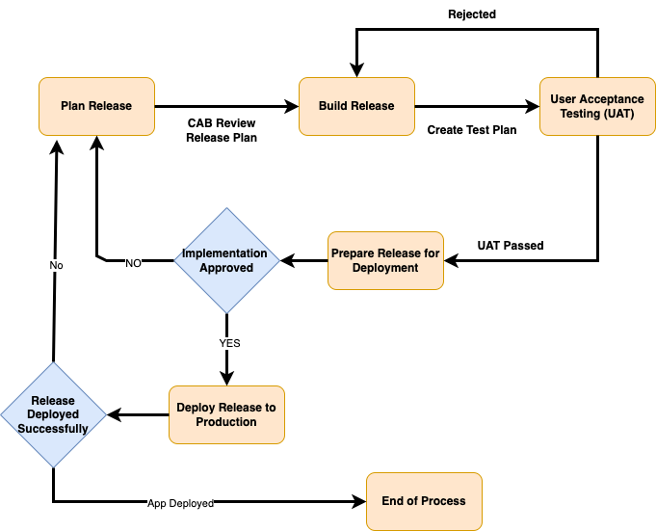

**Figure 2**

**7. Post Implementation**

Lessons learnt and future project enhancements are reviewed and added to the future development roadmap.

# Project Milestones & Deliverable Summary:

The project is constructed from a number of milestones that will be used to assess progress though the project and to ensure all the steps required to deliver the project are resourced with the appropriate people.

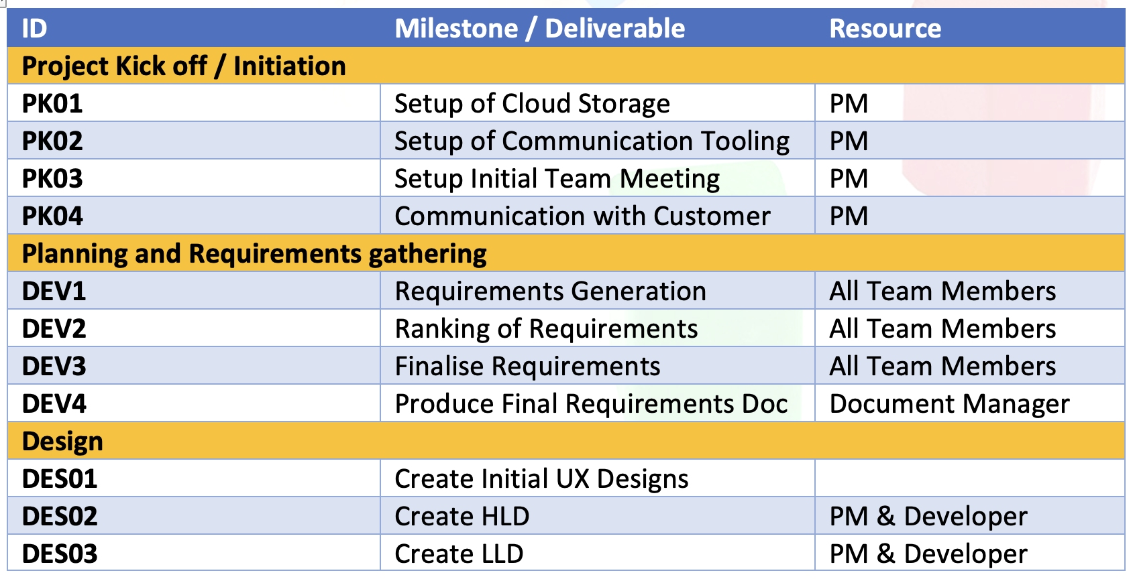

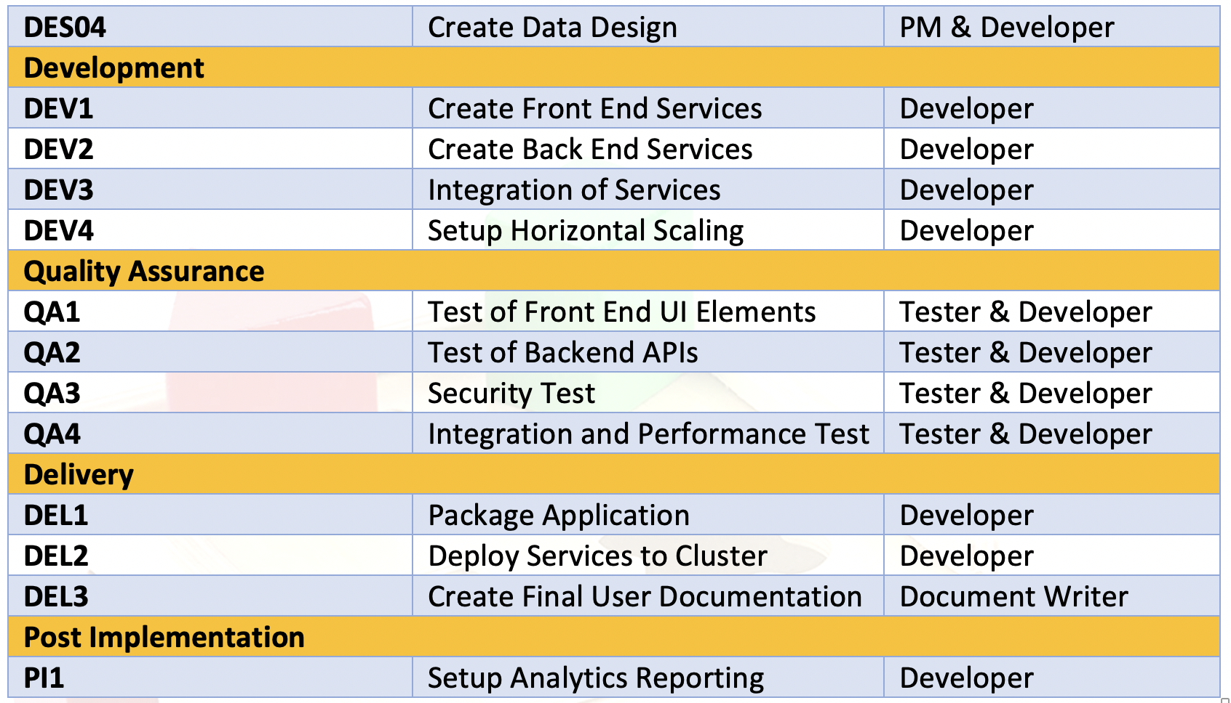

***Table 2***

**Project Stages High Level Roadmap:**



*Figure 3*

Estimated date for project completion is August 29, 2022. Estimated dates for the project phases are shown below.

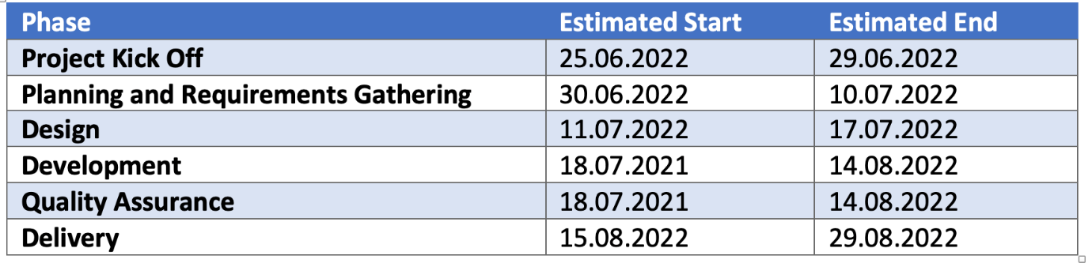

**Figure 3**

# Project Roles:

Within the project, a number of roles will be required at each stage to deliver the project. These are listed below.

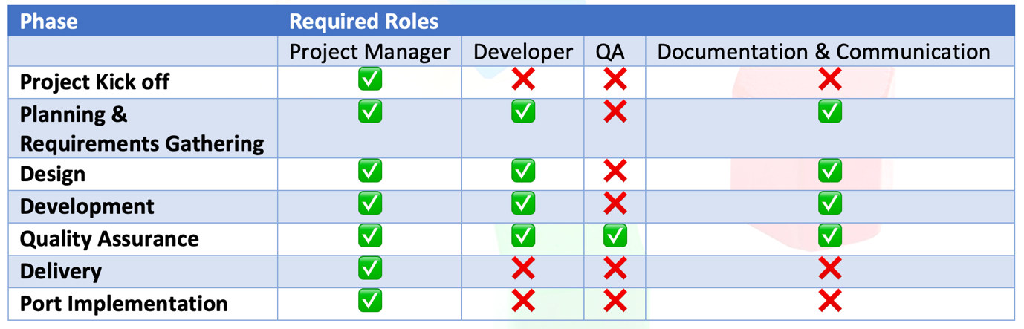

**Figure 4**

# Governance and Delivery Structure:

A structure will be put in place to steer and oversee the workstreams. This will be coordinated by the project manager. Monitoring of the project will be mainly performed by the use of standard project management tooling and weekly 515 status reports. See **Appendix D** for the initial user database design.

# Project Key Contacts:

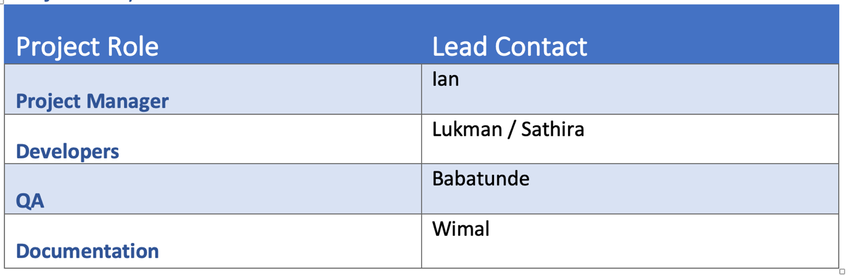

**Table 3**

# Communications:

The documentation project role will carry documentation and communication covering the following areas:

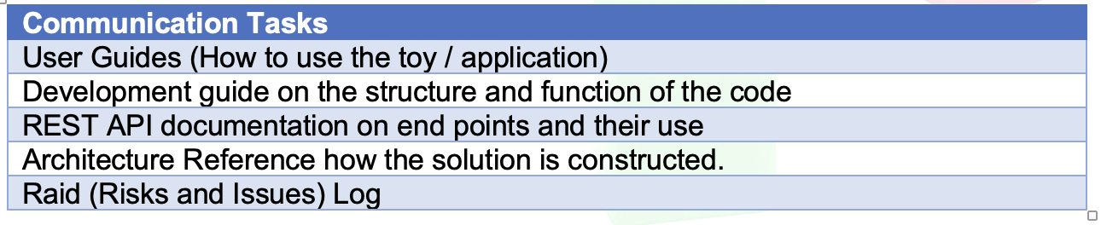

***Table 3***

Along with formal documentation, in cooperation with the project manager, weekly update reports (515) will be produced.

*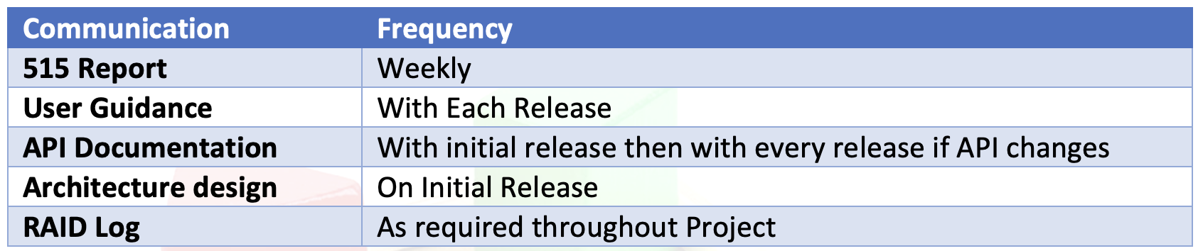****Table 4***

# UAT and Project Acceptance:

The project will be considered to be complete when the following measures have been met:

* Remaining items from the issue log have been closed.
* UAT Testing has been signed off as complete.

# 

# Legal Compliance:

GDPR introduces a right for individuals to have personal data erased. The right to erasure is known as ‘the right to be forgotten’. There is an emphasis on the right to have personal data erased if the request relates to data collected from children. This reflects the enhanced protection of children’s information, especially in online environments, under the UK GDPR. (Anon)

The game user’s personal details are saved in a database where personal details are protected using DBMS and ratified Python encryption libraries.

# Estimated Costings Resource Requirements:

Based on an estimated LOC value of 3000, the results of a COCOMO estimation calculation are:

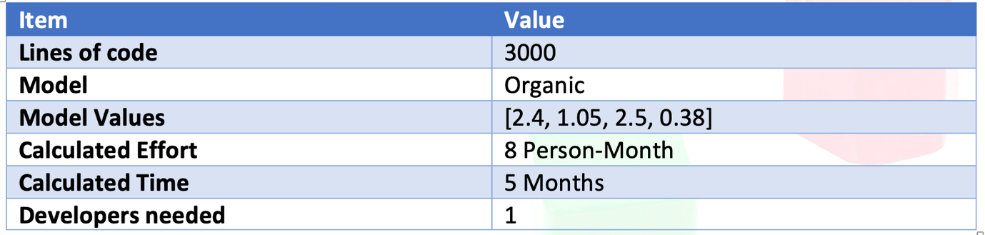***Table 5***

Cost estimates are based on average national UK pay rates for the roles as specified on <https://payscale.com>

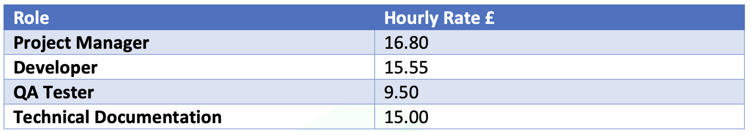

***Table 6***

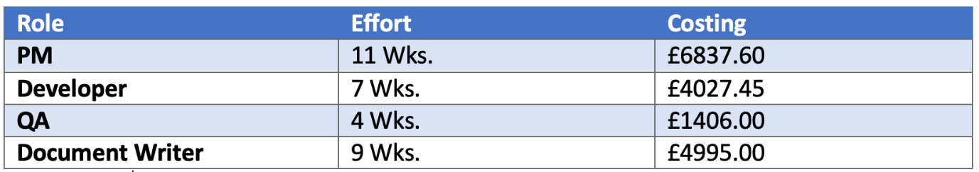***Table 7***

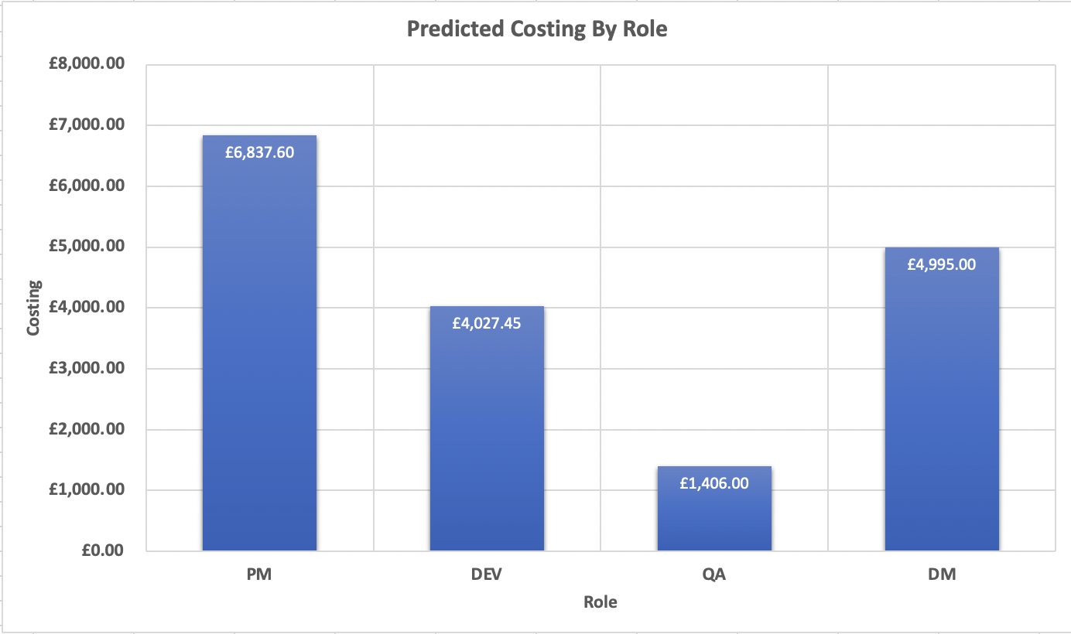

***Figure 5***

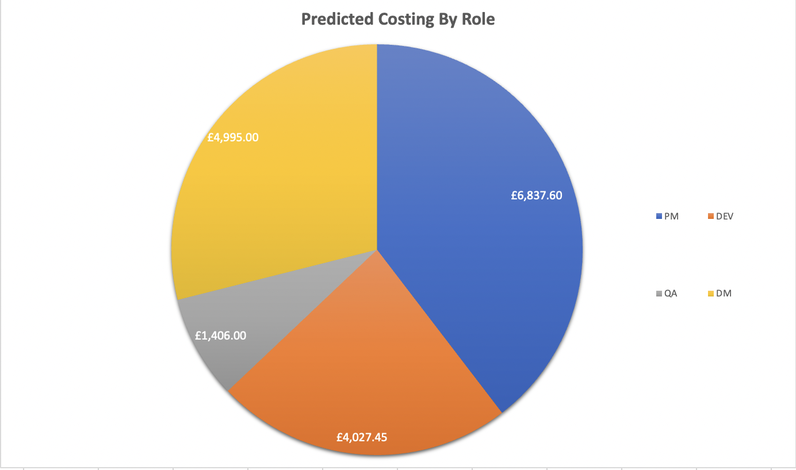

***Figure 6***

# **Indicative Project TimeLine:**

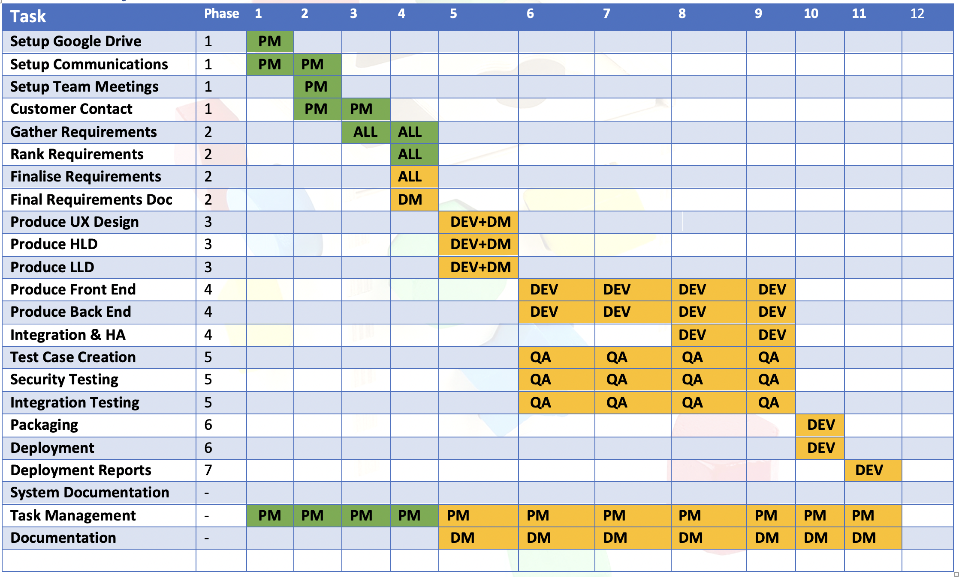

# Predicted Effort by Project Role:

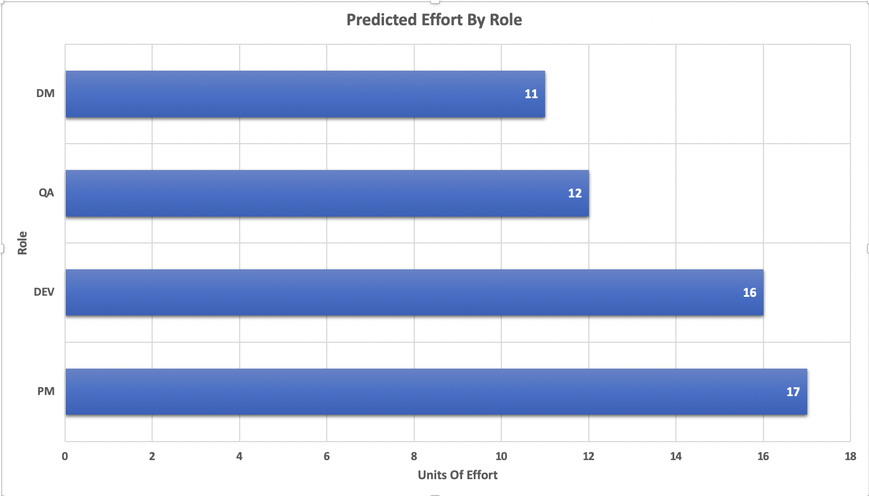

***Figure 7***

# Predicted Effort by Project Phase:

# 

***Figure 8***

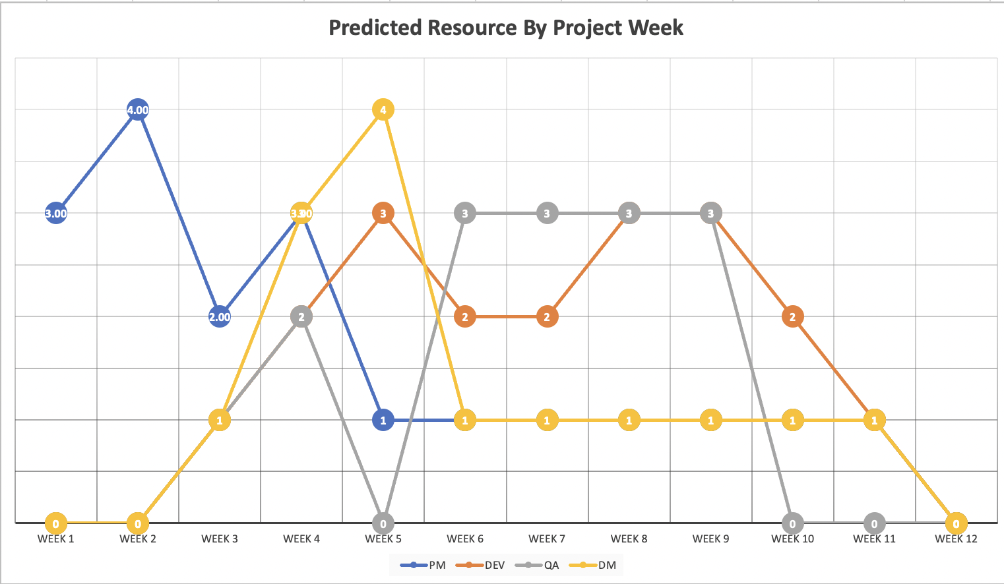

***Figure 9***

**Word Count (Excluding titles and captions): 1057**

# **References:**

Markovic Isidora. (2020). *What Is a Project Management Framework? (Must Read)*. [Online]. Available at: <https://tms-outsource.com/blog/posts/project-management-framework/> [Accessed 30 June 2022].

GDPR (n.d.) General Data Protection Regulation (GDPR). Available at: <https://gdpr-info.eu/chapter-3/> (Accessed: 01 July 2022).

*Right to erasure | ICO*. [Online]. Available at: <https://ico.org.uk/for-organisations/guide-to-data-protection/guide-to-the-general-data-protection-regulation-gdpr/individual-rights/right-to-erasure/> [Accessed 15 July 2022].

Radhika D Amlani, 2012 . Advantages and Limitations of Different SDLC Models. International Journal of Computer Applications & Information Technology Vol. I, Issue III, November 2012 (ISSN: 2278-7720

Mastný, L.Š.L., 2021. IMPACTS OF THE LOCK-DOWN DURING THE COVID-19 CRISIS ON PROJECT MANAGEMENT. The 15th International Days of Statistics and Economics, Prague, September 9-11, 2021.

Statista The most spoken languages worldwide in 2022 [ONLINE] <https://www.statista.com/statistics/266808/the-most-spoken-languages-worldwide/> [Accessed 23 July 2022].

Department of Culture media and sport (DCMS)

<https://www.gov.uk/government/consultations/loot-boxes-in-video-games-call-for-evidence> [Accessed 20 July 2022]

# **Appendixes**

# **Appendix A – Requirements (Gherkin)**

Scenario: System should be established with a resilience architecture design

Given a failure of any of the core system components

When I click on the game button

Then Verify game is playable

Scenario: The game should be playable on both desktop and mobile devices

given that the game is a playable on all devices

When I access the application

Then Verify game screen scaled according to the device

Scenario: @High Demand, the game should support horizontal scaling

Given that the demand for access to the game exceeds the current capacity

when I try to start a game

Then the software should add extra nodes to increase capacity to meet the demand

Scenario: @High Demand, the game should support horizontal scaling

Given that the demand for access to the game is low

and number of nodes is greater than minimum

Then the game should remove nodes to decrease capacity to adjust to current demand

Scenario: The game should automatically update security patches

Given that a security flaw has been discovered in the game

When a new version of the game has been released

Then stop the current game and download the update without the identified flaw

Scenario: The system should support some target languages

Given that the system is switched on

and language switching option is present

When the desired language is selected

Then Verify system presents all dialogues in the selected language

Scenario: The system should boot up in less than a second.

Given that the system is connected to a power source

When the "ON" button is pressed

Then Verify user login screen loads under 1 second.

# **Appendix B - Demo Requirements Justification:**

The system should be capable of search, manage, and encrypt game data in an efficient way:

The Game should be secure by design and this security should be forefront during the design process of the software by choosing to demo this requirement to the customer they will be able to see that the design of the security within our game and platform is sound of high quality and that user’s personal data is respected and handled in accordance with GDPR data processing rules.

The System should update automatically with new content

The reason we have chosen to demo this requirement is that it will show first of all how we handle the application content upgrade cycle of delivering new content to the users of the game it also allows us to talk about the container microservice infrastructure underpinning the delivery of the Game platform and the architectural choices that were made during the project.

The system should support scale out horizontally

The reason we have chosen this to demo is that users don’t like to play a slow unresponsive game this will give us a chance to talk about how we will scale the system to handle many simultaneous user sessions while also giving us a chance to describe the technology stack that has been implemented that enables the system to scale up and down to meet changing customer demand.

The game should support some target languages

The reason this has been chosen for the demo is it covers multiple aspects of our game design it first covers that the game has been designed to be inclusive maximising the target audience by allowing non-English readers

(Statista, 2022)

To access the content of the game and thus maximising potential sales but also shows how we have utilised public APIs supplied by google to enhance and extend the core functionality of the game.

**The Game should have a parental control system**

The reason we have chosen this for our demo is because of the age of the game is targeted at. It is socially responsible thing to do as developers to give parents the ability to monitor and control their children's use of games, and monitor their online activities by the use of built-in parental controls. This will also allow us to demo key game features such as individual gamer profiles.

While our game does not contain loot boxes where the focus of international government interest is at moment (DCMS, 2022) With more government regulation happening across the world in the gaming space. This level of control may become a legal requirement in the future so by adding this parental control feature we are future proofing our application against changes in the legal compliance landscape. Thus, by demoing this part of the system, we are showing our customer how we are acting as responsible developers and are able to adapt to changes in rules around online gaming

**Reference**

Statista The most spoken languages worldwide in 2022 [ONLINE] <https://www.statista.com/statistics/266808/the-most-spoken-languages-worldwide/> [Accessed 23 July 2022].

Department of Culture media and sport (DCMS)

<https://www.gov.uk/government/consultations/loot-boxes-in-video-games-call-for-evidence> [Accessed 20 July 2022]

# **Appendix C - Initial UX Design**

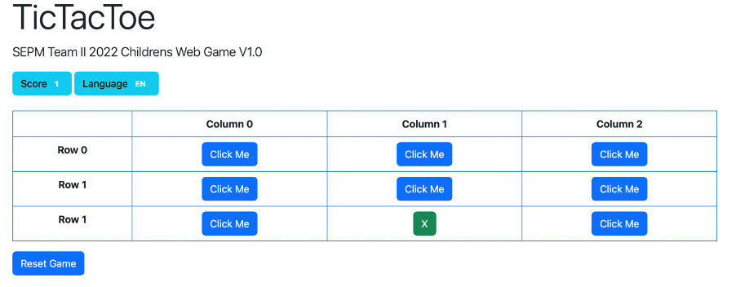

**Dynamic translation of UI Elements using Google Translate API**

1. Dutch

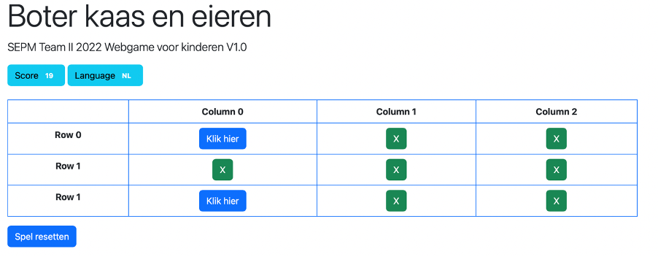

2. Japanese

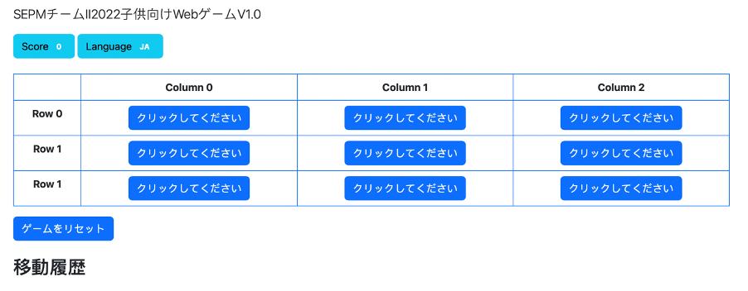

Interface Design

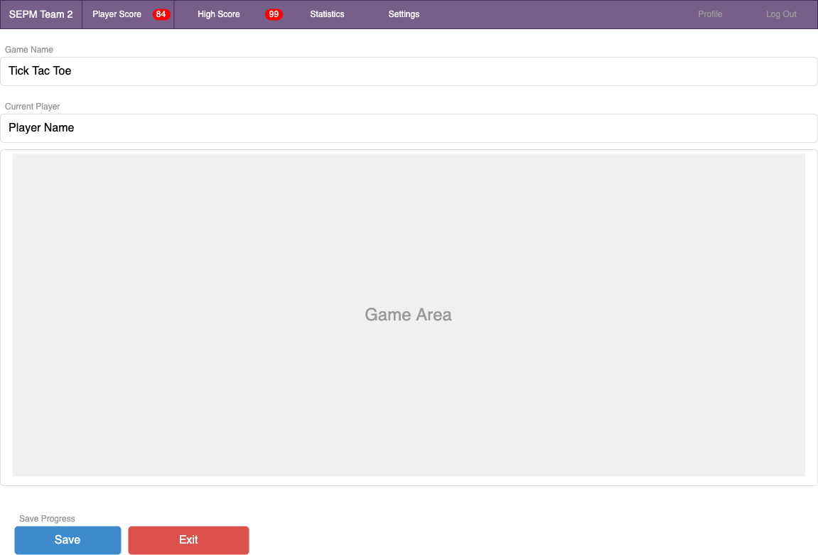

# 

# **Appendix D – Proposed DBMS ERD**

